*FOOD information report using fuzzy logic system*

*STUDENT :MOHAMMAD ALSHAHROR*

*Human bodies are in need for range of nutrition values daily that keep them alive, healthy ,and away from pains.*

*These values are calculated by universal organizations and published to be universal with priorities as :*

1. *Water : comes with the first priority*

*Everybody need 8 cups of water daily or more (2 liters at least)*

*The lake in daily water amount is so dangerous and is the main cause of :*

* *Headache*
* *Concentration problems*
* *Nausea*
* *Cholesterol problems*

1. *carbohydrates :*

*The body needs 300-400 gram of carbs daily*

*More than 400 gram of carbs will be stored as increment in weight*

*Carbs are contained in :*

* *Potato*
* *Bread*
* *Mil*
* *fruits*

*Carbs give energy.*

1. *iron :*

*The body needs 12.5 m.g for women*

*And 9 m.g for men*

*It’s contained in vegetables and some fruits .*

1. *vitamins :*

*as average the body needs 140-150m.g of all vitamin kinds*

1. *protein :*

*Human body needs 1 gram for each k.g weight ( 65-75 g for average people)*

*It’s contained in meats and egg and yogurt .*

*These 5 nutrition values are the most important for human body.*

*But people can’t sum up with all of it’s kinds .*

*So to do that we can make a fuzzy system that takes the amount of nutrition values that the user had in the day and give a report of the daily nutrition information*

*To do that we go through ordered steps :*

1. ***Fuzzification: definition of fuzzy sets, and determination of the degree of membership of crisp inputs in appropriate fuzzy sets.***

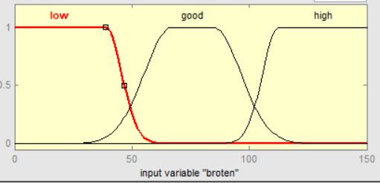

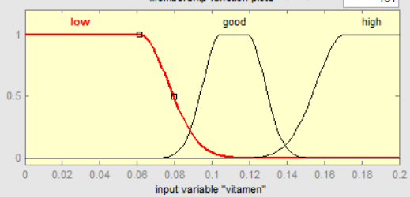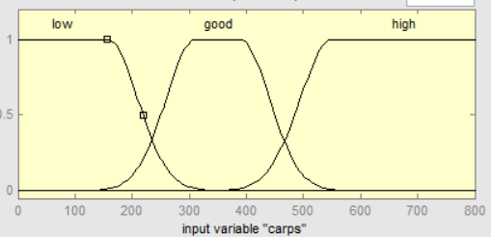

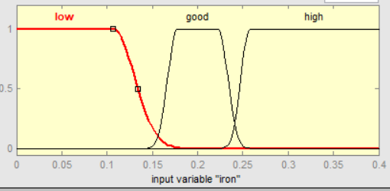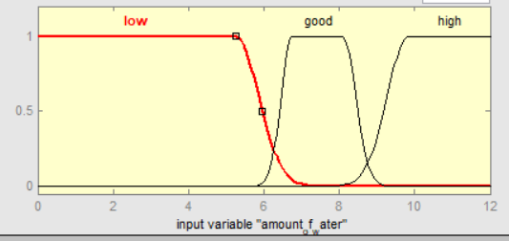

* ***Inference: evaluation of fuzzy rules to produce an output for each rule.***
* ***Composition: aggregation or combination of the outputs of all rules.***

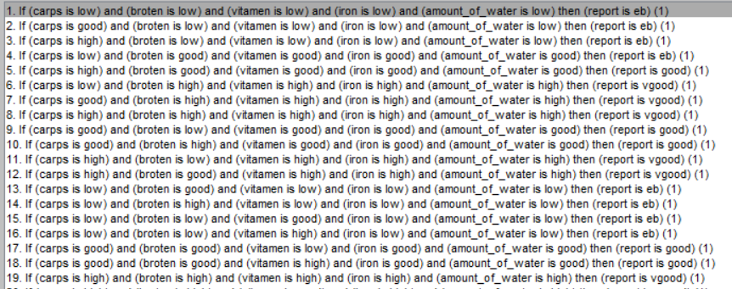

*This done returning to global reports*

*Then after we got the rules we do the last step in fuzzy systems:*

* ***Defuzzification: computation of crisp output***

*(after we compute the output of the 5 inputs we give the final result as a crisp value )*

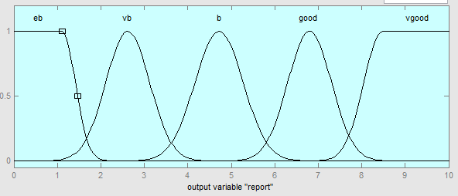

*Simulink:*

